**Creating ‘Hello World’ in Mendix**

1. Go to your project e.g. ‘My First App’ and select Navigation

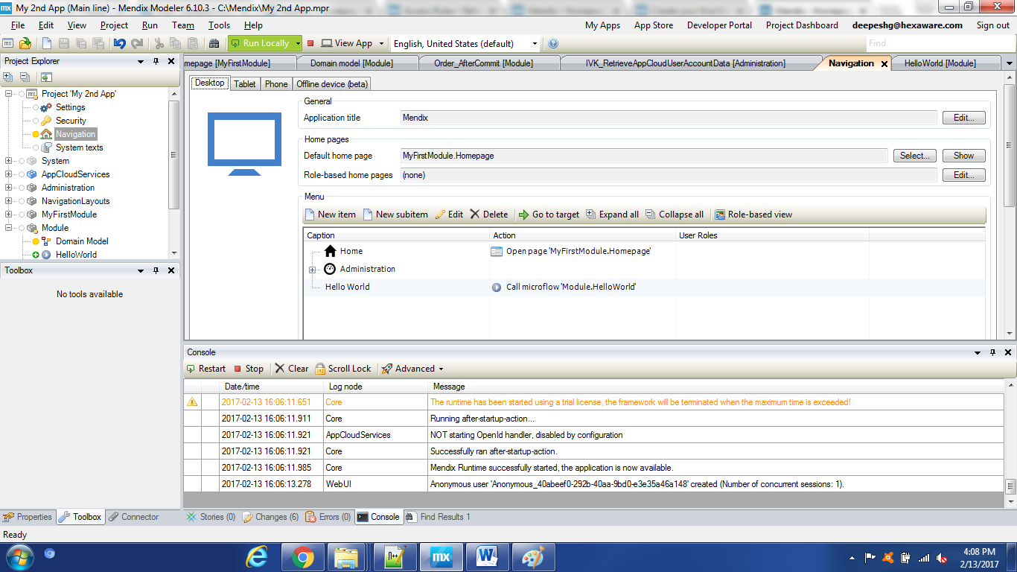

1. Click on ‘New Item’ in the Menu and provide ‘Hello World’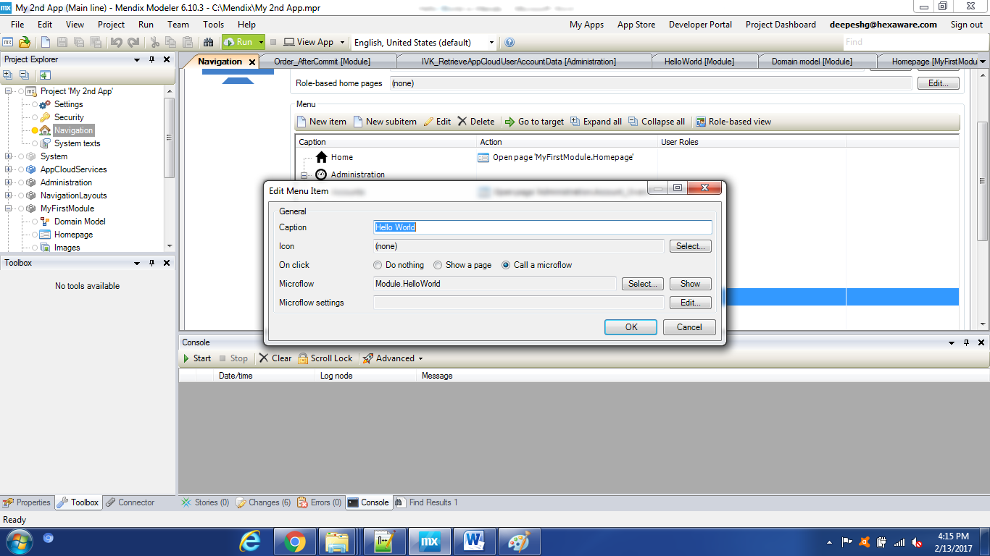
2. Select ‘Call a Microflow’ and click on New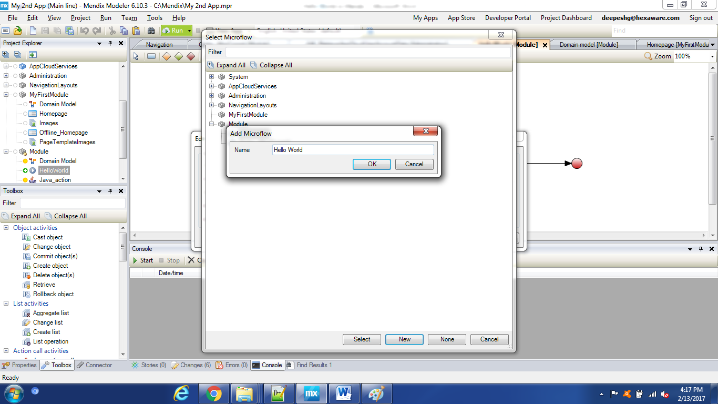
3. Click OK and it will show the selected Microflow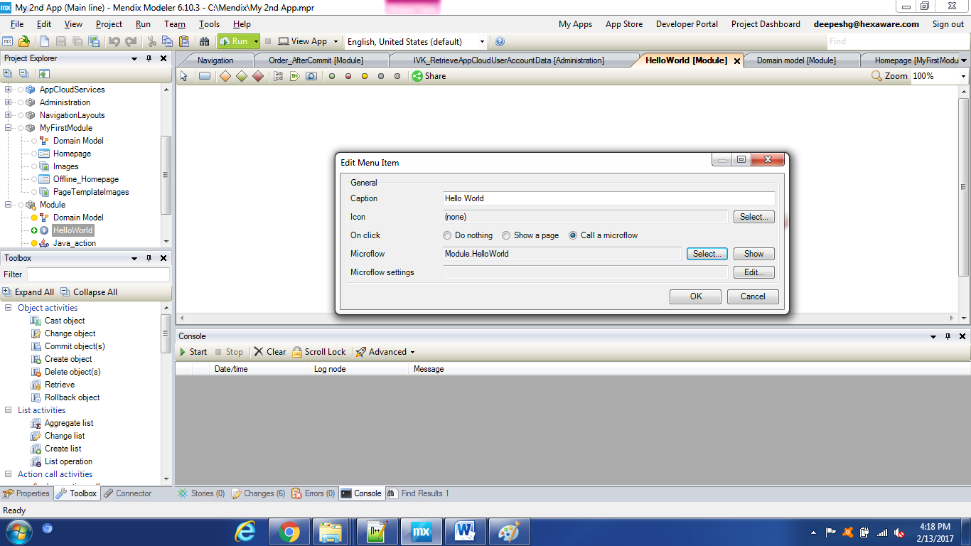
4. Go to Tools and drag ‘Show Message’ between Green and Red circles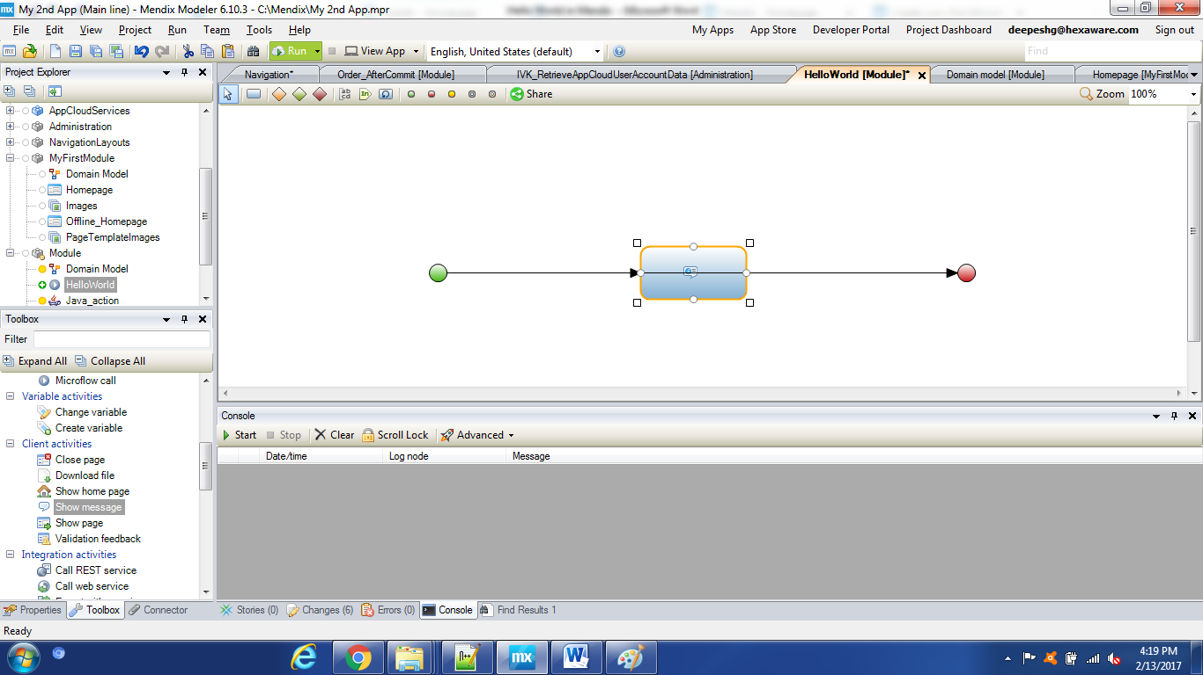
5. Provide any message e.g. ‘Hello World’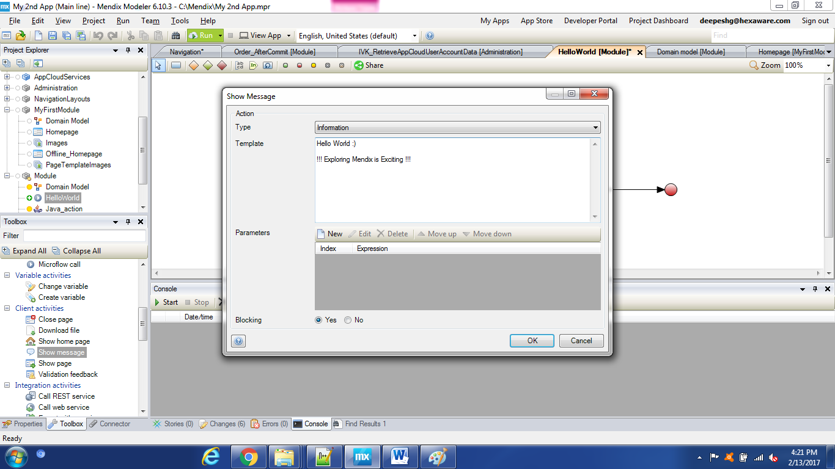
6. Run it Locally and click on View App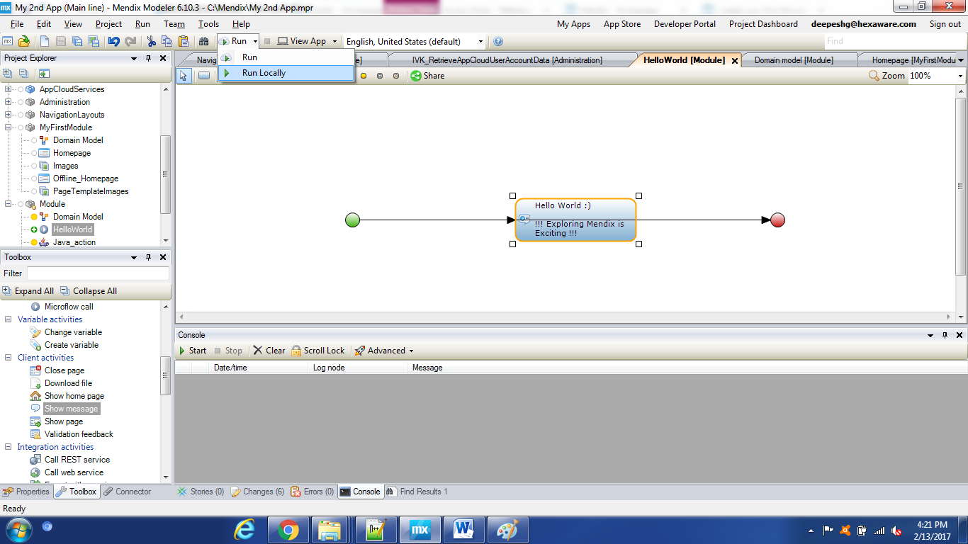
7. You can see the progress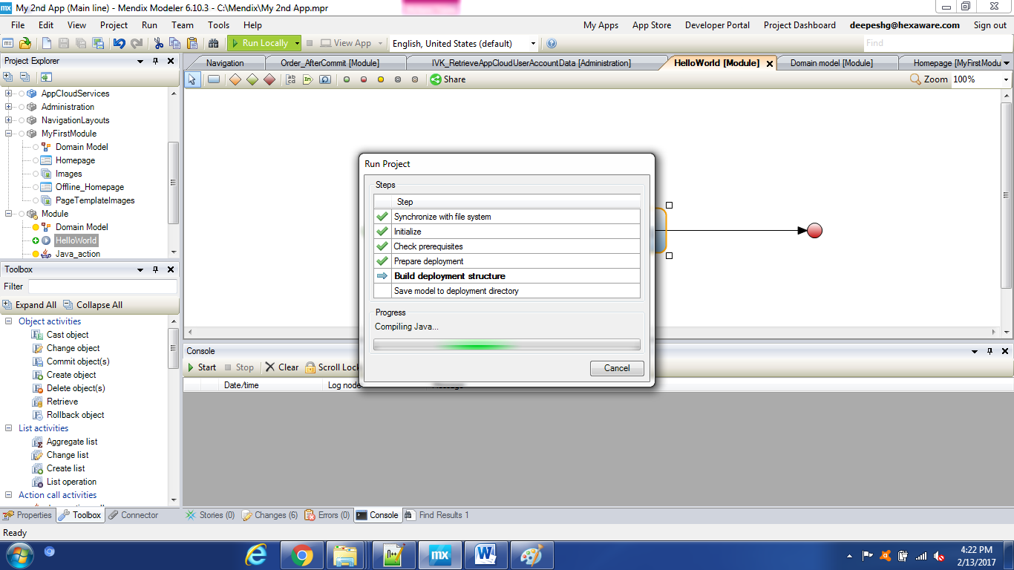
8. Go to Browser and click on ‘Hello World’